We are housed at the Department of Life and Health Sciences, Human Biology Program, of the University of Nicosia, Cyprus

**Research**

We study **digestion and nutrient transport** through the gastrointestinal tract in physiological and pathophysiological conditions using cell culture and animal models focusing on peptides and microRNAs

We are also interested in **inherited kidney diseases** and the molecular mechanisms behind Collagen IV inherited nephropathies.

Finally, we investigate the contribution of individual patient **genotype** and **biomarkers (microRNAs)** in the treatment of various pathologies

**ASPIRE**

Assessment of Post-stroke Aphasia for Rehabilitation Research (ASPIRE) involves interdisciplinary research aiming to improve the quality of life of stroke patients with Aphasia and address the enormous economic burden of post-stroke rehabilitation by attempting to translate scientific knowledge about the effects of non-invasive brain stimulation using transcranial magnetic stimulation (TMS) into applications for clinical practice. The project aims to obtain evidence through a pilot randomised control trial on the effectiveness of treatment protocols using TMS on language recovery after first-time stroke.

Our focus is to incorporate **molecular measures** to assist personalized services regarding assessment, diagnosis, treatment and rehabilitation of people with acute and sub-acute post-stroke aphasia in Cyprus. The general objective is to investigate the **contribution of the individual patient genotype** and **biomarkers (microRNAs)** in the aphasia profile and treatment components as well as the recovery and rehabilitation of people with post-stroke aphasia. Simultaneously, this will allow us to understand the basic neuroscience principles underlying principles of rehabilitation, mainly brain plasticity at the individual level. Recovery after stroke occurs on the basis of specific molecular events. Genetic polymorphisms (SNPs) and specific miRNAs have been associated with impaired neural repair or plasticity which might reduce recovery from stroke and might also account for some of the inter-subject variability in stroke recovery.

This project is funded by the Cyprus Research Promotion Foundation under Excellence Hubs 2016 (EXCELLENCE/1216).

**School pupils work for sustainable landscapes**

SUSTAIN, an Erasmus+ network

The new European SUSTAIN network has been awarded a EUR 449,900 grant by Erasmus+, the EU programme for education, training, youth and sport. The network will be coordinated by Science LinX, the science centre of the University of Groningen (UG) Faculty of Science and Engineering with the University of Nicosia being a partner. SUSTAIN aims to engage pupils and their families in research projects – what is known as citizen science on aspects of sustainability. The 12 partners will develop e-learning modules on ‘sustainable landscapes’ and research in Spain, Cyprus and the Netherlands, linking learning inside and outside the classroom.

For SUSTAIN, the million-dollar question is how society can use landscapes for industry, housing, agriculture and recreation without hampering biodiversity. This is a major issue for future generations, and young people must therefore be included in the discussion.

The project members – researchers, school teachers, science education providers and experts in science communication – will form a community of learners (CoL) and will develop e-learning modules on a topic relevant to the region. These will be made available to other schools in the third and final year of the project. At the end of the project, each of the three countries will host a science festival to reach a wide audience.

Project website here: <https://www.sustainablelandscapes.eu/>

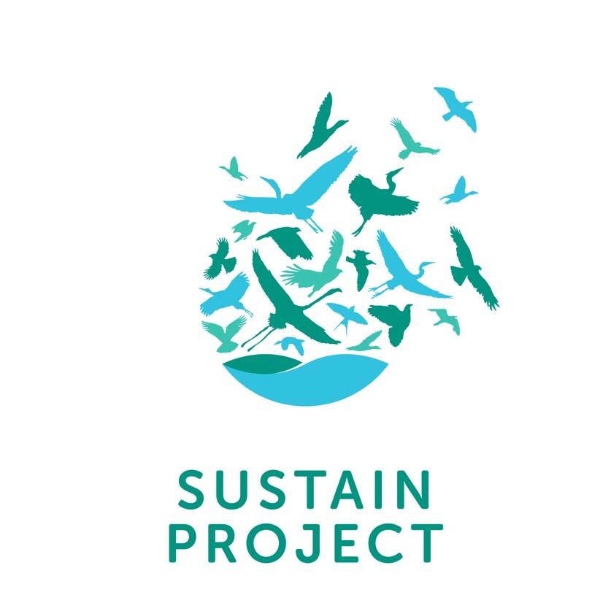Image:

**Bovine XenomiRs as a novel potential mechanism for Colorectal Cancer (CRC) initiation and progression [Acronym: “MicroFOOD”]**

**“MicroFOOD” is a proof-of-principle study testing whether selected ingested beef miRNAs have the potential to regulate human genes initiating or adding to the progression of colorectal cancer. Specifically, upregulated miRNAs in CRC patient biopsies will be identified (Aim 1) and correlated to enriched miRNAs found in edible parts of beef (Aim 2). Five tumorigenic miRNA candidates will be selected after bioinformatic filtering (Aim 3) and studied: a) through human digestion (Aim 4), b) for their effect on human intestinal epithelial cells (Aim 5), c) on their putative transepithelial transport via the gut (Aim 6). Identification of beef miRNAs as the link between diet and CRC will have imperative implications for prevention, risk-assessment and therapy of an increasingly frequent human cancer while add to the growing and controversial field of “cross-species regulation by dietary miRNA”; a phenomenon that could revolutionize our understanding of the effect of diet on human disease.**

**Figure:**

**Principal Investigator**

I direct the Pieri Lab at the Department of Life and Health Sciences, University of Nicosia, based in Nicosia, Cyprus.

My lab’s research is focused on gastrointestinal physiology and nutrient transport in various physiological and pathophysiological conditions. We are also interested in inherited kidney disorders and the role of the Unfolded Protein Response (UPR) in human pathology. We have incorporated a repertoire of in vitro and in vivo models to address our research questions. Cell culture, migration, proliferation, wound healing assays, in vitro digestion models, animal models of disease and more. We are also interested in Science outreach and Education related to Human Anatomy and Physiology.

**Interests**

Nutrient transport

microRNAs

Unfolded Protein Response Pathway (UPR)

Collagen IV Nephropathies

**Education**

PhD in Human Anatomy and Physiology, 2007, University of Oxford, UK

BA in Biology, 2002, University of Patras, Greece